**206CDE- Real World Project – Lecture Group 3, Project Group 5 – Disaster Zone**

**PROJECT PLAN/ SOFTWARE SPECIFICATION**

**Team Introduction**

|  |  |  |
| --- | --- | --- |
| **Student ID** | **Team Member** | **Team Role** |
| 6393896 | Oliver Bell | Project Management, Programming |
| 6248622 | Zac Davies | Programming |
| 5965771 | Peter James | Systems implementation, databases |
| 6212900 | Kieran Goodson | Design, Storyboarding |
| 6457556 | Joe Robinson | Databases, UML |
| 6441485 | Liam Judge | Interface design, Video Editing |

**Problem Definition**

In the event of a large-scale, life threatening disaster, do societies of the modern digital age possess enough common sense and/or knowledge to survive unless their mobile phones tell them so? For example, in the event of a Tsunami, would people know:

* What exactly the particular hazard is and what happens?
* What the warning signs of the hazard are?
* Where to seek immediate refuge?
* Which supplies to get and where to find them?
* Who to call in the event of a casualty?

**Introducing Disaster Zone**

Disaster zone will be an Android application that provides users with information regarding natural disasters, how to survive them and where to get supplies from.

**Minimum Viable Product (MVP)**

The MVP for Disaster Zone should include the following features:

* Provide basic information about each of the following hazards
* Provide a basic survival guide about each of the following hazards
* Provide a basic list of equipment/supplies in the event of the following hazards

**Hazards covering in Disaster Zone:**

**Geological Disaster**

* Earthquakes
* Sinkholes
* Avalanche and landslides
* Volcanic eruptions

**Hydrological Disasters:**

* Floods
* Limnic eruptions
* Tsunamis

**Meteorological Disasters:**

* Tornados
* Heatwaves
* Hailstorms
* Thunderstorms
* Droughts
* Cyclonic storm
* Blizzards

**Other Disasters:**

* Household disaster
* Pets disasters
* Solar flares
* Impact events and airbursts
* Wildfires

It should be stated that this is the minimum and the team will be working to implement more of the desired and advanced features as listed in the problem definition. We will be developing iteratively and believe it is important to get the basics completed primarily. Then and only then can we work on adding extra functionality as well as more aesthetic updates to the user interface and graphics.

**Target Audience:**

Our target audience is generally quite broad as a real life disaster affects just about anyone who comes into range with one. However as the users will require an android device to be able to use the app and could be assumed to have the desire and/or initiative to survive we could place our target audience within the aged 16+ demographic, both male and female.

**Market Research:**

There are a number of disaster orientated apps on the market at the moment, most of which act as an alert system for incoming or current disasters. The gap in the market for our app, Disaster Zone, is the additional information and functionality that it will provide. Most of the apps out there do not provide in detail help or tips about survival and do not have the ‘supplies in your area’ section. Here are a few of the current disaster based apps on the android market available.

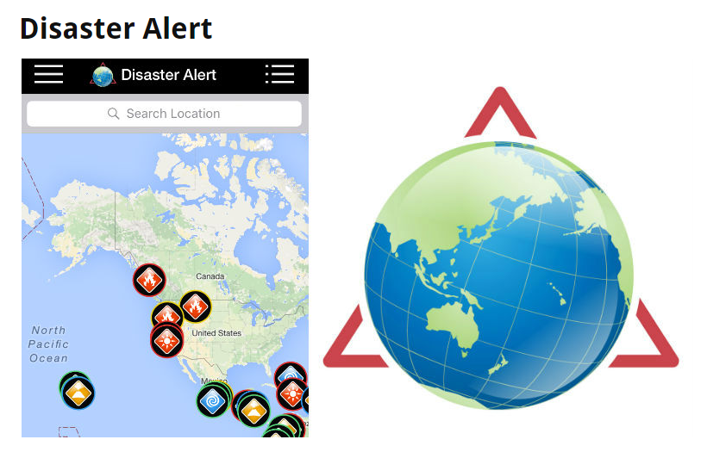

**Disaster Alert** works as an interactive map that provides users with real time notifications on local or global disaster. It’s been designed to alert people of disasters that are ‘potentially hazardous to people, property, or assets’. The interface is sleek and plain. The app offers map and list form of current events happening around the world with one main sidebar featuring all of the settings and map legend. Disaster alert offers simple, factual information about events and somewhat of the history of a particular locations past with them.

**Emergency Red Cross** is more similar to the multi-functional application that we are hoping to have by the end of the project. It covers emergencies ranging from car breakdowns, to terrorist attacks to fog. Not only does it provide real time alerts of potential hazards in your area but it also allows you to enter locational details of your friends, relatives or loved ones. We were particularly interested in this application as it had an advice and preparation section offering text and images to help users in such event. Disaster Zone ideally will have something similar implemented.

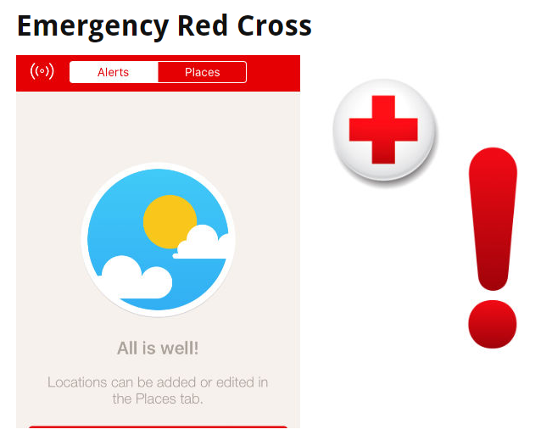

**Communication, Meetings and Version Control**

The team are going to be using Github which will be the centre for version control. Each member will commit their work to the group repository where it will be reviewed by the project leader and accepted.

The team meet every Monday between 1-3pm during our Monday group session where we work on the application, discuss any problems and submit any intermediate bits of work that we need to. We also have a meeting between 4-5pm on the same day in the library where we discuss each individual’s task that is to be completed before the next time we meet.

**Key Challenges**

* Time management if the Gannt chart is not adhered to strictly
* Retrieving the locational data from user’s devices as well as the locations of the nearest stores
* Creating /finding a database that contains a list of supplies that local stores have
* Creating a clean, minimalistic, professional and intuitive looking application that is to be used in a serious and emergency situation

**Project Timeline (Gantt chart)**

This is the Gantt chart that the group will adhere to. We firmly believe that if the project is to succeed then we need to stick with this regimented schema closely. Time management is always amongst one of the primary issues with project work. If we can’t get something done within each week’s time limit then we are to move on with the next thing and then come back to it if there is time.

